The explorer review
By Leighton
It was set in the 1950s

The plot
A plane crashes when the pilot starts choking shutting the engine down in the Amazon now diving at extraordinary speed leaving the plane in debris and the four children Max, a five year old midget, his overprotective older sister Lila,Con the moodie and she doesn't like being called concertina and finally the more of a leader Fred.left by themselves They all have to survive find food water and shelter to survive or will they read this amazing book to find out.This book is full of adventure so read it to find out what happens.
Highlights
Some of the best parts of this book is when they travel down an unknown river to find Manous, you know that capital city of brazil in the Amazon.Or when they crash and find themselves with a snake on Freds boot and run for their lives.Mabe when they find the unknown explorer.
Weakness
I think they need to improve talking about the children, mainly Fred and Lila because they don't really talk about them And describing the explorer too.
Favorite quote
“He's mine now.“said Max, taking the vulture for himself.
Would you recommend this book and why
Yes Because it’s full of mystery,adventure and you feel like what comes next. Also you really want to know what happens next.It has lots of excellent parts that i haven't said so you can read it and find it out yourself.
Emotions while reading
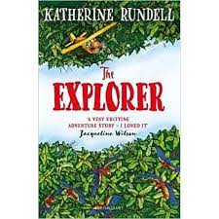
While you read you would feel a bit of laughter.In some parts while reading and in a certain part you will feel a bit of terrible sadness mainly when Max stands on a bullet ant colony.

